- List and describe each of the four ways the Duration of a Move Steering Block can be set in order to have a robot move.
- What is the difference between the Brake and Coast settings in a Move Steering Block’s next action?
- If Ziffle’s Tribot travels 15cm with a duration setting of 500 degree, what duration setting should be used to have the Tribot travel 50cm?
- Describe how a tribot would behave with this program block (include 4 facts):
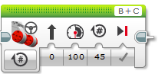
- Describe how a tribot would behave with this program block (include 4 facts):
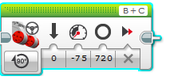
- Describe how a tribot would behave with this program block (include 4 facts):
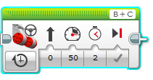
- Describe how a tribot would behave with this program block:
